1. **INTRODUCTION**

Lifeshades Photography project a system which help the users to login and make a reservation for photo-

shoot & video-shoot (includes pre-wedding, wedding, baby-shower, birthday, food, maternity,

model shoot, etc).

Customers can view packages according to there event/venue functions.

Payment can be made online/offline as per user choices. Users can directly contact with admin for

any query or more details.

* + **Problem Statement :**

Existing system is a manual one in which users need either to call a service centre . Admins needs to maintaining books to store the information like Employees details, Bookings, Order details . It is very difficult to maintain historical data.

The following are the disadvantages of the existing system. It is difficult to maintain important information in books.

It is tedious to manage historical data which needs much space to keep all the previous year data. Daily Booking details must be entered into books are very difficult to maintain .

* **Purpose of System :**

Proposed System:

The old fashioned ways of organizing a studio will consume a lot of precious time and effort.

The system provides clicked photos for reference and also recommends images based on the

information provided by the users.

Essentially, the purpose of photography is **to communicate and document moments in time**.

When you take a photograph and share it with others, you're showing a moment that was frozen

through a picture.

Photography may be used both **to capture reality and to produce a work of art**. While

photo manipulation was often

frowned upon at first, it was eventually used to great extent to produce artistic effects.

* **Objectives of the System:**

The function of a photographic objective is **to image light from more or less distant objects to some image plane**, where either a photographic film or an electronic image sensor is placed. ... Even multi-lens objectives are often called photographic lenses.

* **Objectives To understand the basic techniques of photography.**  
  To compare traditional film and digital cameras and photography.To analyze the various equipment which can enhance photography.To create a quality photograph using basic rules and technology.To discuss the impact of photography in publications.
* **Chapter Links The Camera Film vs. Digital**  
  Equipment, Accessories & Necessities What Makes a Good Photograph
* **Project Scope:**
  + 1. Lifeshades Photography involves Photography, creation and development of different Order ,
    2. like a parties , includes pre-wedding, wedding, baby-shower, birthday, food, maternity,
    3. model shoot, etc.
    4. Lifeshades Photography a career is a multi faceted activity .
    5. This career role demands an ability **to photograph** all kinds of newsworthy people, places,
    6. sports,political, and community events for newspapers, journals, magazines, or television.
    7. A photojournalist must possess a journalistic sense to shoot a good news picture.
    8. website should display your photos in a visually pleasing layout that's easy to navigate.
    9. It's primary purpose is **to present your photos to the world**, rather than sell something
    10. or publish articles.
  + **Limitation**
    1. Order cannot be created, dropped or altered by another stored program, trigger or event.
    2. Value clumping- Our eyes see a broader range of values than cameras. ...
    3. Edges- Our field of vision focuses on one object at a time and makes all other edges softer. ...
    4. Perspective- A camera will read the objects closest to the lens as larger than reality.
    5. First of all, the early forms of photographic process (the daguerreotype, the ambrotype, the tintype and the albumen print, to name the most common ones) were very difficult to learn and perform, expensive in terms of their equipment and apparatus, and sometimes very dangerous (for example, developing a daguerreotype ...

1. **System analysis**

* **Existing System**

The existing system is very problematic as it involves the data storage i.e., keeping the records of all the Customers, Vehicles and Admin manually. Also maintaining the customer records through files and books is tedious job.

We can imagine that as the information storage is there, it requires the various data stores which may be registers or diaries to note the respective details. And from these data stores the retrieval of required information is also difficult as we have to search all the records until we do not get the desired information. So, to avoid all these problems this project is required.

* **Scope of System :**

Photography - Career Scope & Job Prospects  
  
 This career role demands an ability **to photograph** all kinds of newsworthy people, places,

sports, political, and community events for newspapers, journals, magazines, or television.

A photojournalist must possess a journalistic sense to shoot a good news picture.

This career role demands an ability **to photograph** all kinds of newsworthy people, places,

sports,political, and community events for newspapers, journals, magazines, or television.

A photojournalist must possess a journalistic sense to shoot a good news picture.

website should display your photos in a visually pleasing layout that's easy to navigate.

It's primary purpose is **to present your photos to the world**, rather than sell something

or publish articles.

**3 System Design**

* **Database Dictionary :**

**Admin:**

|  |  |  |  |  |
| --- | --- | --- | --- | --- |
| Field name | Data Type | Constraints | Size | Description |
| admin_id | int | Primary key | 15 | Unique id of  admin |
| admin_name | char | Not null | 30 | Name of admin |
| admin_phone | numeric | Not null | 10 | Phone number |
| admin_email | varchar | Not null | 30 | Email id of  admin |
| admin_password | varchar | Not null | 15 | Password of  admin |

**Employee:**

|  |  |  |  |  |
| --- | --- | --- | --- | --- |
| Field name | Data Type | Constraints | Size | Description |
| employee_id | int | Primary key | 30 | Employee id |
| employee_name | Varchar | Not null | 20 | Name of  employee |
| employee_email | varchar | Not null | 20 | Email id of  employee |
| employee_phone | numeric | Not null | 10 | Phone number |
| admin_id | int | Foreign key | 15 | Reference id of  admin |

**Customer:**

|  |  |  |  |  |
| --- | --- | --- | --- | --- |
| Field name | Data Type | Constraints | Size | Description |
| cust_id | int | Primary key | **15** | Customer id |
| cust_name | varchar | Not null | **20** | Name of  customer |
| cust_phone | numeric | Not null | **10** | Phone number |
| cust_email | varchar | Not null | **20** | Email of  customer |
| cust_address | varchar | Not null | **30** | Address of  customer |

**Services:**

|  |  |  |  |  |
| --- | --- | --- | --- | --- |
| Field name | Data Type | Constraints | Size | Description |
| service_id | int | Primary key | 15 | Service id |
| cust_id | int | Foreign key | 15 | Reference key of  customer id |
| employee_id | int | Foreign key | 15 | Reference Key of  employee |
| admin_id | int | Foreign key | 15 | Reference key of  admin |
| service_details | varchar | Not null | 50 | Service details |
| service_location | varchar | Not null | 50 | Location details |
| payment_id | int | Foreign key | 15 | Payment id |

**Payment:**

|  |  |  |  |  |
| --- | --- | --- | --- | --- |
| Field name | Type | Constraints | Size | Description |
| p_id | int | Primary key | 15 | Payment id |
| payment_mode | varchar | Not null | 20 | Mode of  payment |
| timestamp | timestamp | Not null | 6 | Time |
| payment_details | varchar | Not null | 20 | Payment details |

* **DFD diagram :**

**DFD Diagram 0 Level**

Check/Manage

Database

Lifeshades

Photography

Order

Request

Client

User

Admin

Manager

**DFD Diagram 1 Level**

User

Login

Admin

Login database

Order

update

Manager

Order base

Select / view

Payment

Payment database

Venue

Payment

mode

Consist of

Admin

Id

Event

Lifeshades

Photography

Amount

Organized

by

Or no

User

Email id

* **E -R Diagram :**

Gender

Contact

User type

User

Or manager

id

Name

Email

control

Consist of

Date

Timing

User id

Payment mode

* **Use Case Diagram :**

Registratio

Login

Order

Selection

**ADMIN**

**USER**

Manager

Profile

Payment

Log out

**MANAGER**

* Activity Diagram :

Request Again

Customer Login

Customer request for order

management



Admin Check Request

Approve

Yes

Admin assign Employee to customer

for Order management

Employee does All the Order

Management

Customer Pays Payment

* **User Interface:**

Every user should have –

* Basic knowledge of computer and mobile.
* Must have Basic knowledge of English.

1. **Implementation details :**
   * **Hardware and Software Requirements:**

* **HARD DISC: 160 GB**
* **RAM: 256 MB RAM**
* **PROCESSOR: Intel core Processor**
* **PROCESSOP SPEED :1.60 GHz.**

**Software requirement**

* **The software requirements are:**
  + **Frontend/language – HTML**
  + **Database – PHP/MySQL**
  + **Additional Tools – XAMPP**
  + **Operating Sytem - Windows**

  

1. **Outputs and Reports Testing**
   * **Unit Test :**

It is software component testing. It is lowest level testing. Unit is a module. The purpose of unit testing is to ensure that the program or the component is reliable & meets requirement.

* + **Integration Test :**

The objective of this testing is to demonstrate that the software modules which comprised of interfaces, interact in a correct & stable manner. Consideration is also given to user expectation regarding the look, the feel & the performance of the application under the testing.

**Sample Input & Output Screen :**

**Home Page:**

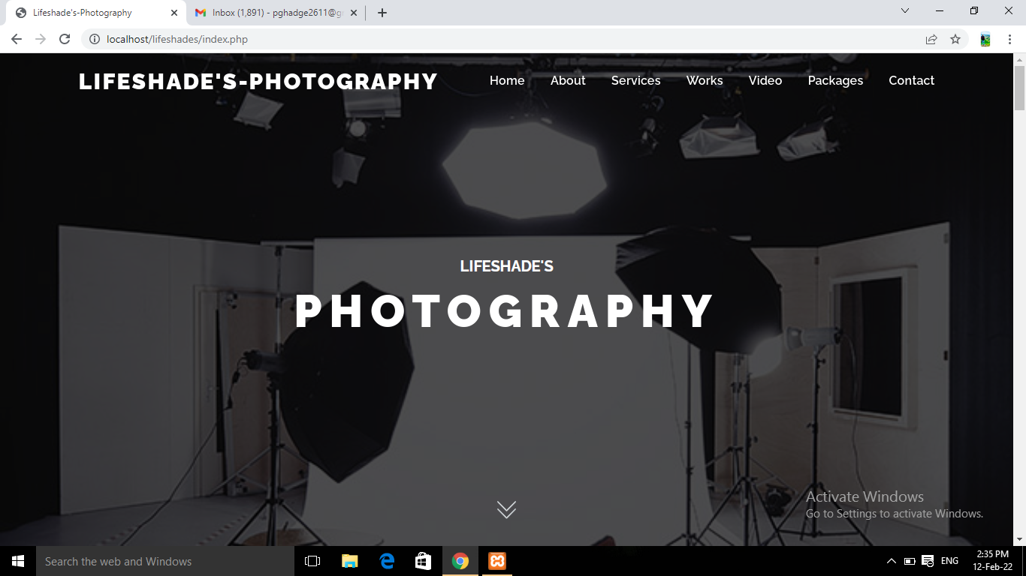

**About Page:**

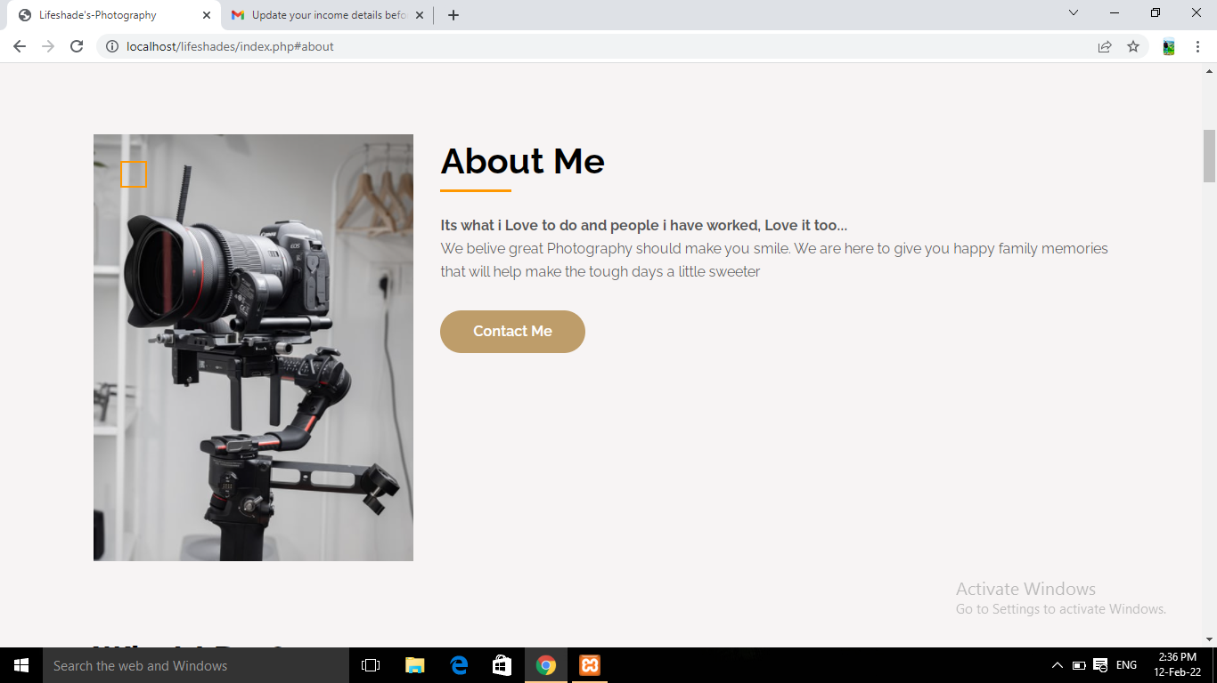

# What I do page:

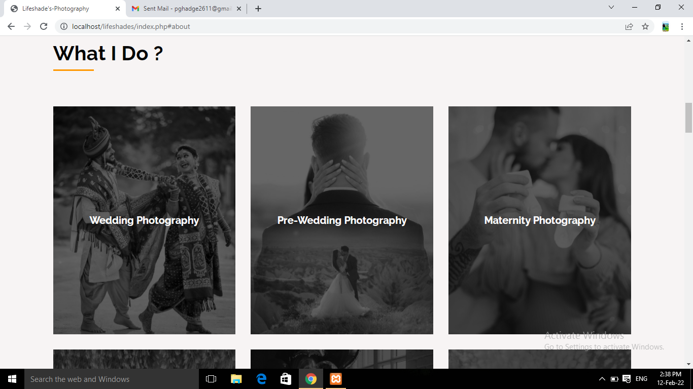

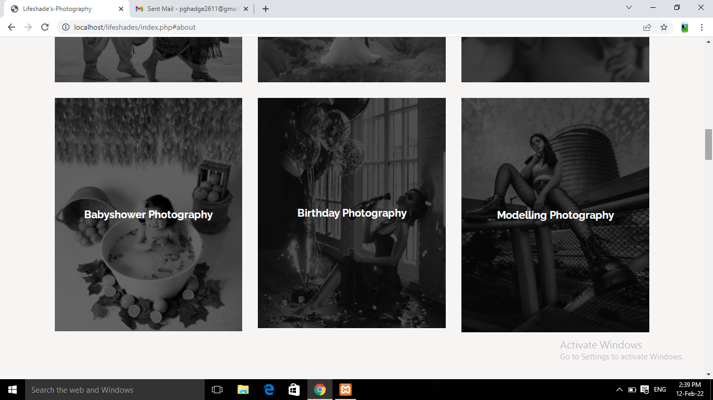

**My Work:**

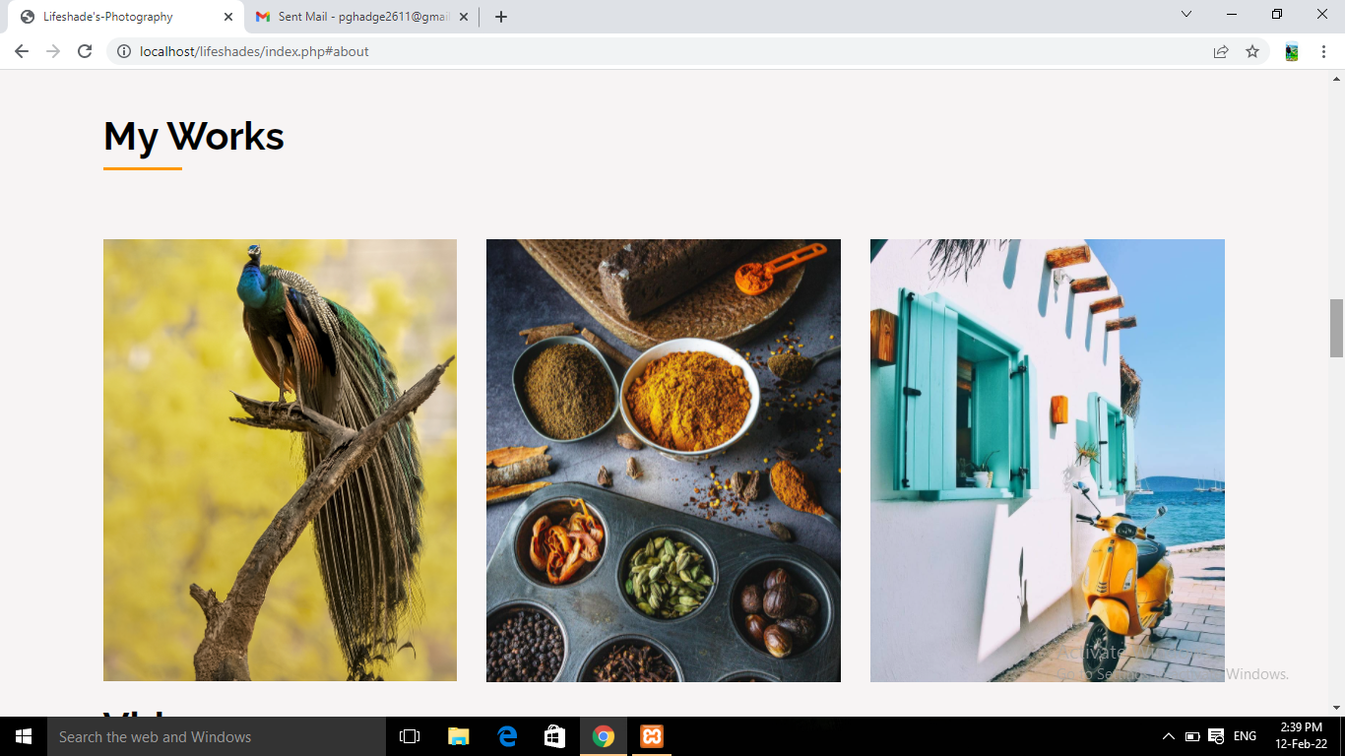

**B**

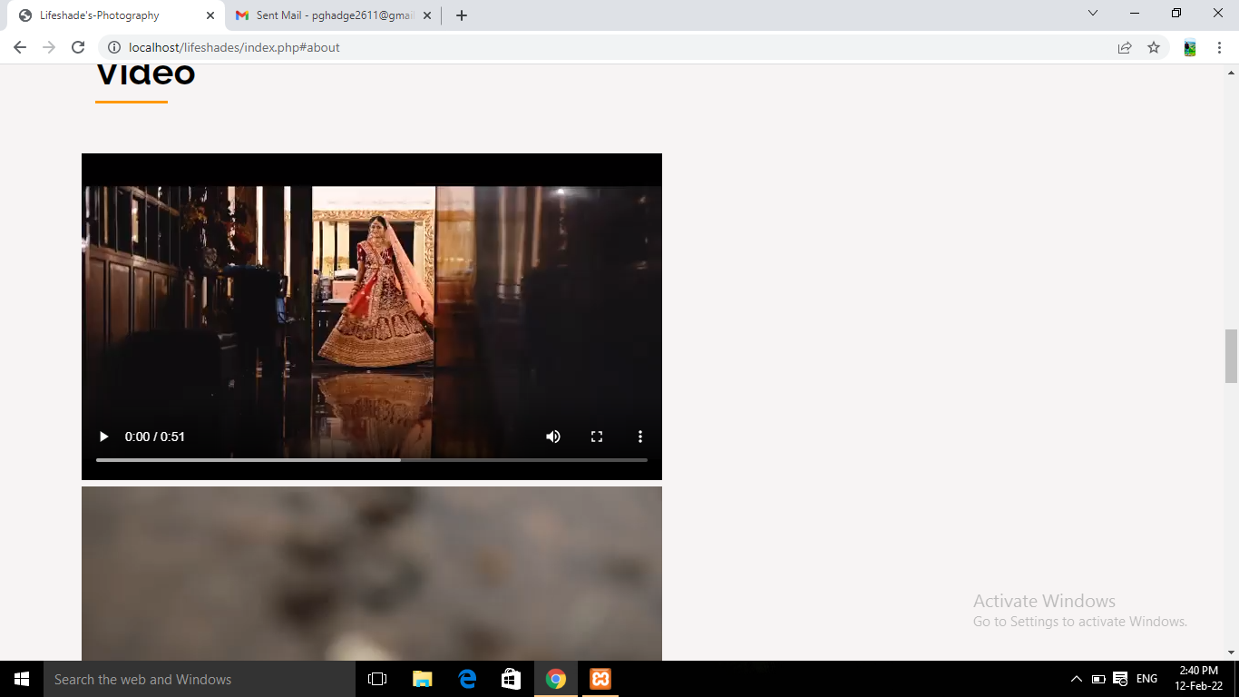

**Video:**

**Packages:**

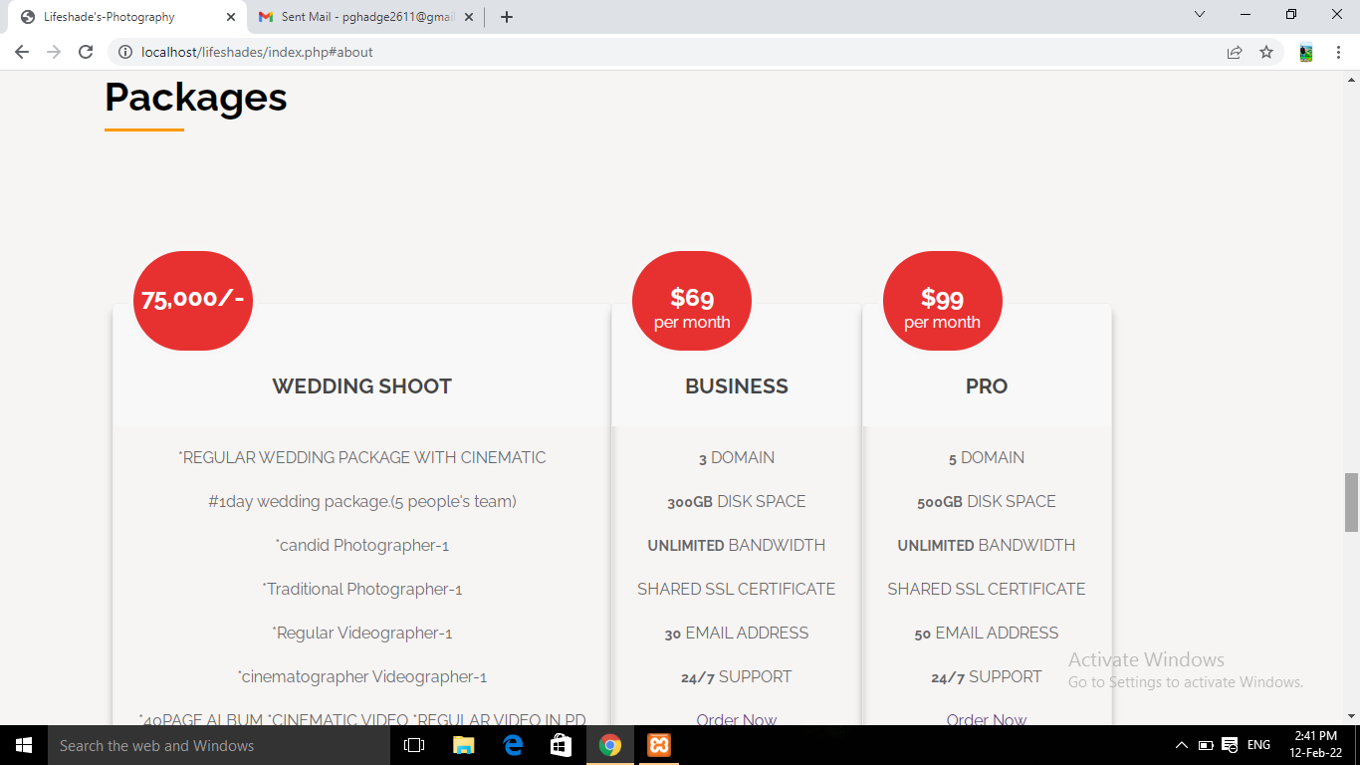

**Contact Page:**

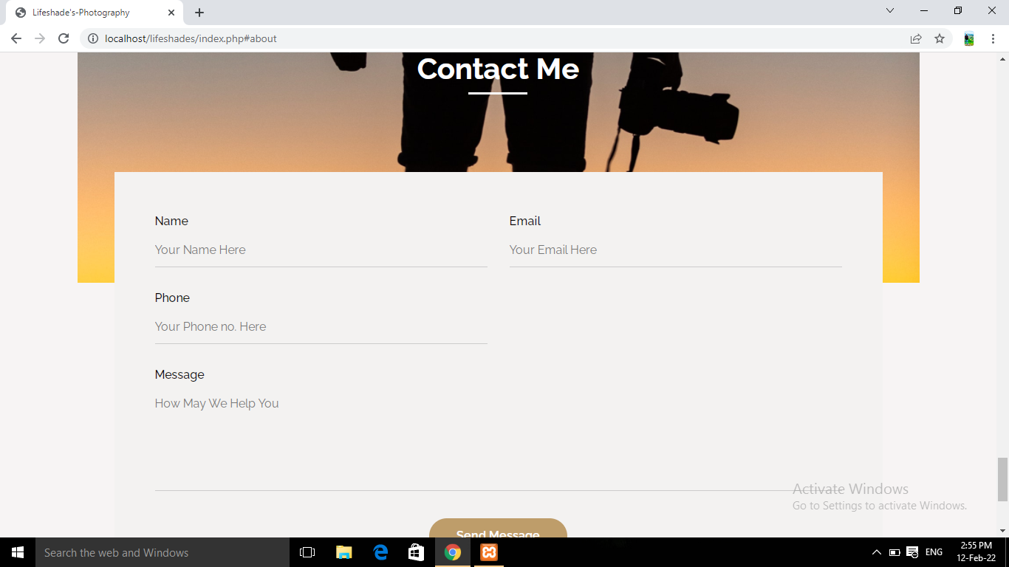

1. **Conclusion:**

* The System was designed in such a way that future modifications can be done easily.
* System security, data security and reliability are the striking features
* Updating and deleting of information becomes so easier.

• The System has adequate scope for modification in future if it is necessary.

1. **Future Scope**

* The System has adequate scope for modification in future if it is necessary.
* Give a facility to send a text message or email to the customer regarding their request to our system (accepted or rejected)
* Include internet banking Create a receipt of the amount paid.
* Employment of photographers is projected to decline 8 percent from 2016 to 2026. ...
* Demand for portrait photographers will remain as people continue to want new portraits.
* In addition, corporations will continue to require the services of commercial photographers to

develop compelling advertisements to sell products.

1. **Bibliography and References :**

* Google for problem solving.
* Wikipedia.com
* Phptpoint.com
* [https://phpgurukul.com/event management-system-using-php-and-mysql/](https://phpgurukul.com/event%20management-system-using-php-and-mysql/)

.➢https://phpgurukul.com/tag/online-event-management-saystem